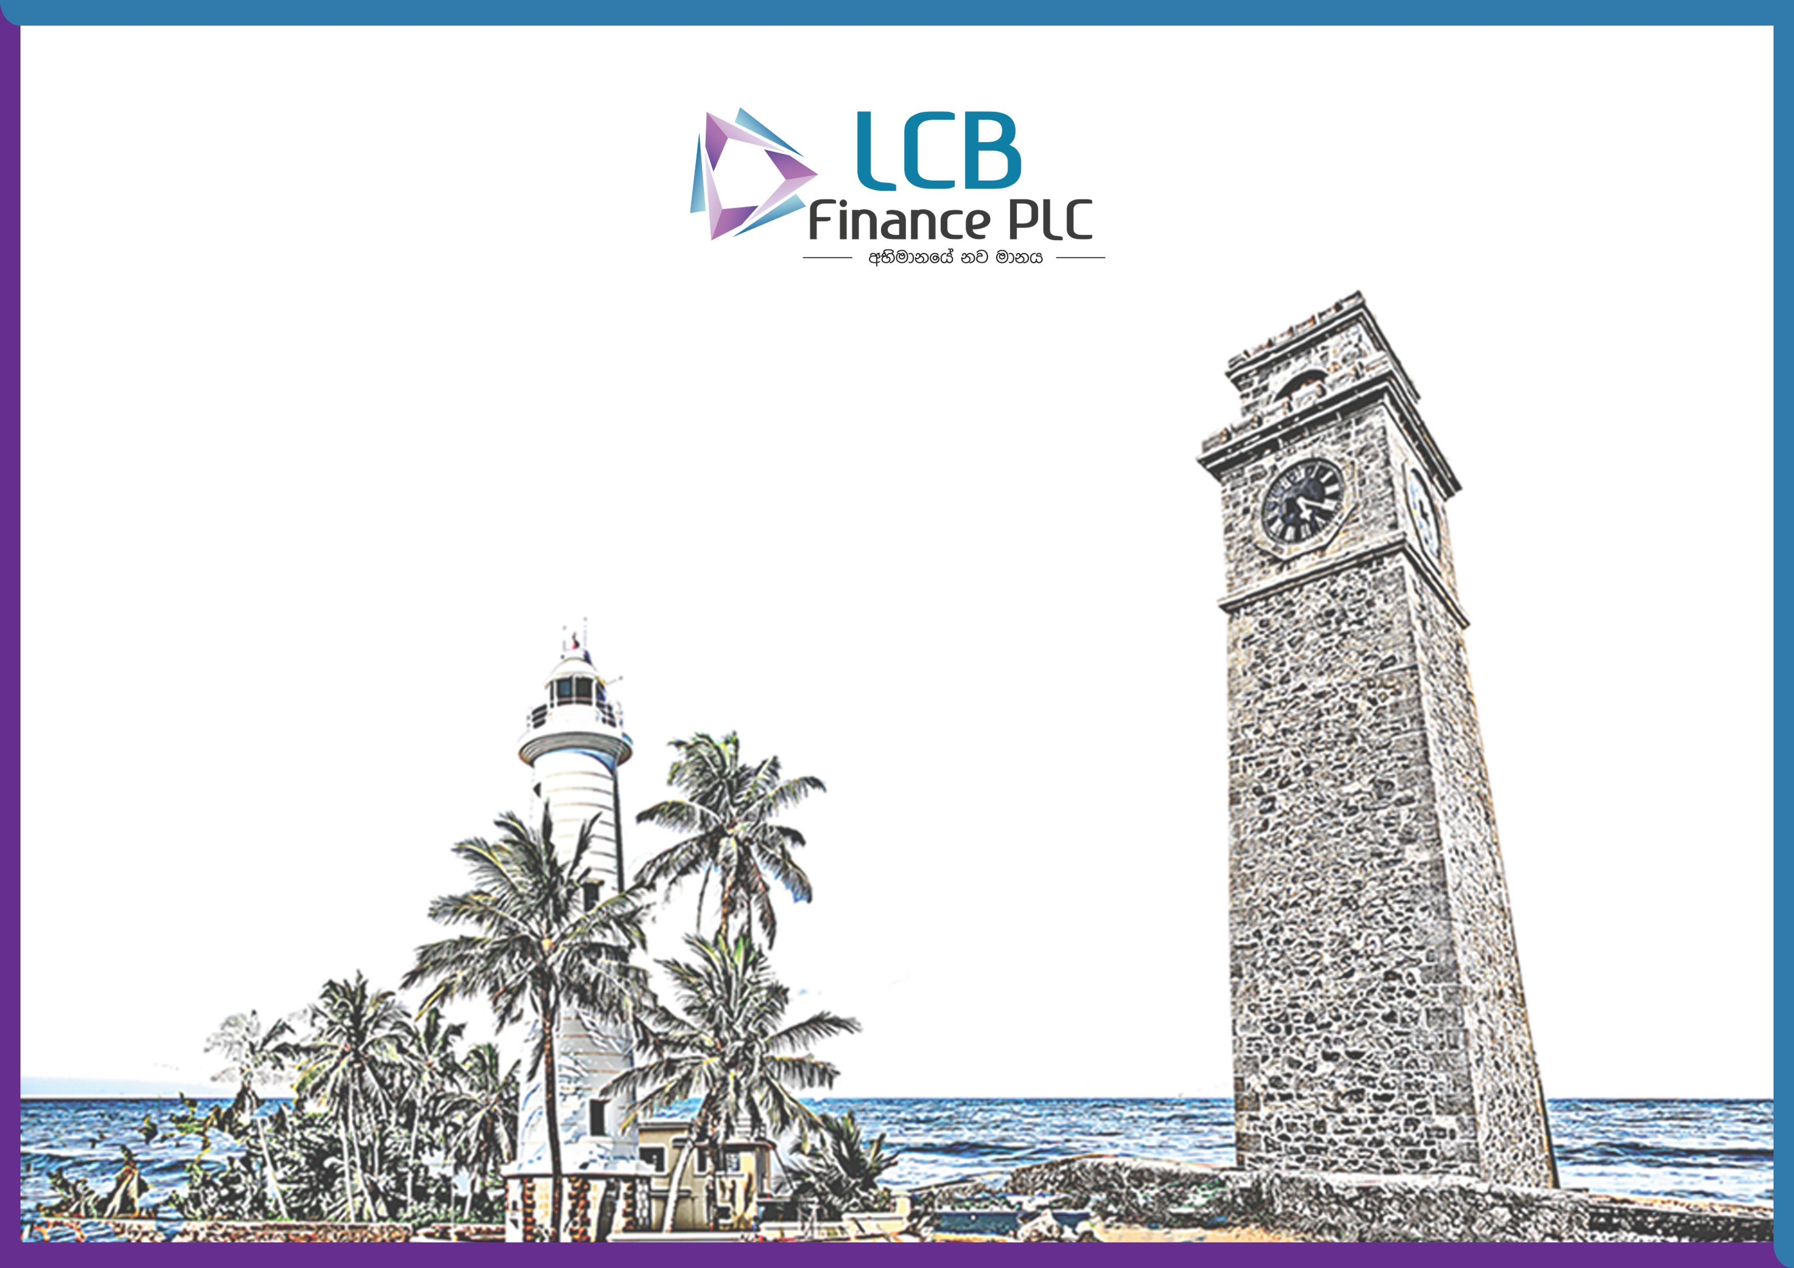

KEY FACT DOCUMENT

LANAKA CREDIT AND BUSINESS FINANCE PLC

KEY FACT DOCUMENT

CASH BACKED FACILITIES
Description: Cash backed loan facility is the best way to get money for your urgent needs without withdrawing your FD’s and savings balances placed with us.

Product/ Service | Benefits  Incentives/ Promotions | Interest / Charges | Procedures to be Followed | Major Requirements / Conditions
CASH BACKED LOANS | - Speedy service at your door step.  - Flexible repayment method.  - Personalized service through trained staff.  - LTV-Maximum up to 90% of the FD Value (Conditions apply)  - Minimum documentation | Rate of interest will be 3% over and above the deposit rate. | - Duly completed application form  - Surrender of Deposit, Receipt or Savings pass book  - Copy of NIC or Valid Passport with NIC Number  - Letter of Set-off | - Mark lien in the system and Record on Receipt or Pass Book as Appropriate  - Maximum period 5 years  - Age over 18 years
This document serves to comply with the requirements of the Finance Customer Protection Framework issued by the Central Bank of Sri Lanka Direction No 1 of 2018.

LOANS SECURED BY IMMOVABLE PROPERTIES (BUSINESS OR HOUSING)

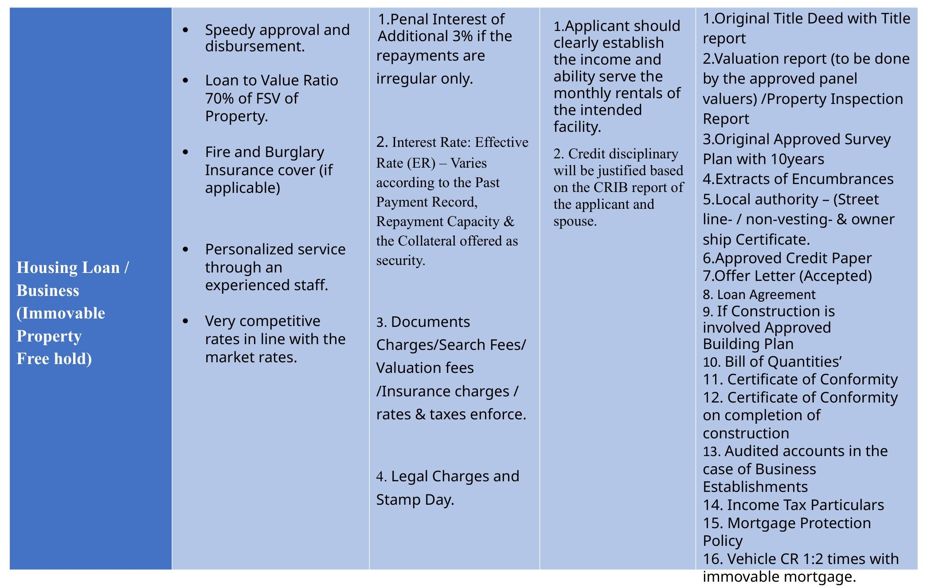

This document serves to comply with the requirements of the Finance Customer Protection Framework issued by the Central Bank of Sri Lanka Direction No 1 of 2018.

LOANS AGAINST PERSONAL GUARANTEES

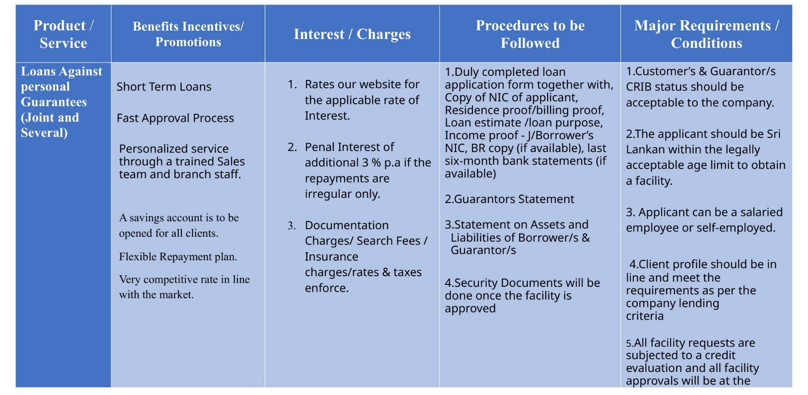



This document serves to comply with the requirements of the Finance Customer Protection Framework issued by the Central Bank of Sri Lanka Direction No 1 of 2018.

GOLD LOAN
Apart from our extensive range of financial services, one of our most well-liked products in the Sri Lankan market is a service we call "Gold Loan." For your convenience, all of our branches provide the LCBF Gold Loans service. This will assist our esteemed clients in quickly meeting their short-term working cash needs to maintain a smooth operation of their businesses.

Product/ Service | Benefits Incentives/ Promotions | Interest / Charges | Procedures to be Followed | Major Requirements / Conditions
GOLD LOAN  Providing instant Loan facility to the agreed period with the pledge of Gold, article. | - Maximum advance amount based on the best value in the market  - Very attractive and competitive rates compare to the prevailing market rates  - No hidden costs or chargers in addition to the interest charged  - Faster service and safekeeping of your valuable gold items  - Flexible Repayment Options available for 1, 2, 3, 6, 9 and 12 months based on your preferences  - Minimal Documentation  - SMS services to reduce the delivery time  - You can repay after receiving profits from your Crop, or after harvesting  - Relevant Gold article will be taken as a security | - Advance as a percentage of Gold value  - Interest rates are based on the market conditions, & subject to  revision from time to time (please refer our website for the Interest rates).  - Other charges are also based on the , advance amount and the market conditions, subject to revise from time to  time. | - Should provide a valid National Identity Card (NIC)/Driving License/passport.  - . After verifying the pledging gold articles weight, caratage the advance amount will be decided.  - Gold Loan Ticket /Receipt | - Sri Lankan Nationals over 18 years of age holding a valid National Identity Card / Valid passport / Driving license  - Minimum facility of Rs.10,000/-  - Gold Loan advance based on the value of gold, articles pledged.  - . The facility will be available at the terms and conditions of the company of all required documents

This document serves to comply with the requirements of the Finance Customer Protection Framework issued by the Central Bank of Sri Lanka Direction No 1 of 2018.

LEASING & Power Draft

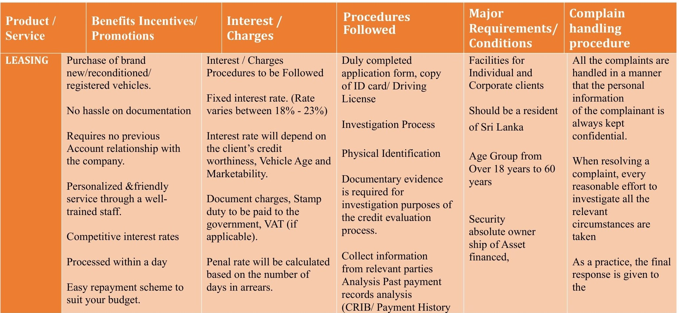

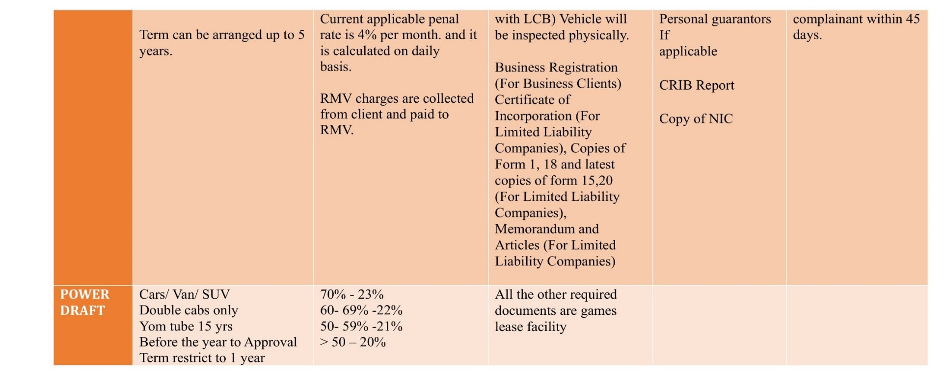

This document serves to comply with the requirements of the Finance Customer Protection Framework issued by the Central Bank of Sri Lanka Direction No 1 of 2018.

“SIHINA” AYOJANA (Investment Savings)

Product/ Service | Benefits Incentives/ Promotions | Interest / Charges | Procedures Major Requirements / to be Conditions  Followed
This is a product designed for a customer to set aside a fixed amount of savings every month to achieve a target amount at the end of an agreed period ( Minimum of 1 year and a maximum of 3 ) | - A monthly savings commitment to reach a targeted amount at the end of agreed period.  - Interest calculated daily and added to the account monthly.  - Deposit insurance coverage available. | - Interest rates are based on the market conditions, & subject to revise from time to time.  - Converted to a smart savings account, if agreed monthly savings amount is not deposited. | - Mandate should be duly completed with monthly agreed amount  - KYC Requirements should be completed  - Copy of NIC in the absence Driving License or passport which carries the NIC Number  - Withholding Tax  Declaration | Sri Lankan Resident Over 18years  Pass Book
3. When Pre mature account closure, applicable interest rate will be only the prevailing
LCB “Samart”
savings interest rate.
This document serves to comply with the requirements of the Finance Customer Protection Framework issued by the Central Bank of Sri Lanka Direction No 1 of 2018.

SMART, RAJINI & PODITHTHA

PRODUCT DOCUMENTS ELIGIBILITY COMMENTS REQUIRED CRITERIA
SMART SMART/RAJINI SMART/RAJINI FACTORS TO CONSIDER OPENING & MAINTAIN SAVING ACCOUNT

RAJINI PODITHTHA
- Duly completed LCB • Individuals who are Finance PLC Savings Citizens/ Resident / Mandate / Identification Dual Citizens of Sri
Document (NIC/PP/NDL) & Lanka and age above
KYC Document.
18 years.
- Copy of recent utility bill/ Bank statement to establish or change the residential address
  - Initial Deposit Rs.500
  - Minimum Balance Rs.500 should be maintained to earn interest
  - Interest will be calculated on daily basis and will be credited to the account at the end of the month.
  - Cash withdrawal allowed from any Branch solely by the account holder. Third party withdrawals are not permitted.
  - Value added services will be provided on request.

PODITHTHA
    - Mandate/ Birth certificate.
      - Parent/ Guardian Identification Document (NIC/PP/NDL) & KYC
PODITHTHA

PODITHTHA Accounts will be opened for children below 18 Years of age parent or guardian as Signatory
- Cheque deposits into the saving account will be at the sole desecration of the management. •Customer should check entries relating to deposits/ Withdrawals and Balances.
- Passbook or statement account will be issued at the request of the customer.
- Minor account Withdrawals are not allowed until the minor attends 18 years.
- Minor account can be transferred to another Bank or Finance Company on completion of 60 Months from the date of first deposit at the request of Parent/Guardian
- Withdrawals are permitted for a justifiable reason such as medical & education of the minor for justifiable reason acceptable to LCB finance.
- Lost/ Damage of passbook indemnity should be submitted.
- Deposit insurance coverage available.

This document serves to comply with the requirements of the Finance Customer Protection Framework issued by the Central Bank of Sri Lanka Direction No 1 of 2018.

FIXED DEPOSIT

Key Features and benefits to financial consumers | - Interest rates are based on the tenure starting from 1 month to 60 months.  - Interest will be paid at maturity or monthly as per the choice of the customer.  - Ability to obtain loan facilities up to 80% (if interest paid monthly) and 85% (if interest paid at maturity) from the Fixed Deposit value.
Minimum Balance  requirement | Rs. 10,000/=
Opening Fee | No opening fee
Maintenance Fee | No maintenance fee
Deposit insurance  Coverage | Maximum up to Rs. 1,100,000 based on the amount deposited.
Restrictions on opening account/closing account/ transfer of funds by customers | - A Sri Lankan resident over the age of 18 years is allowed to open Fixed Deposit accounts. However minor Fixed Deposits are accepted along with a guardian as a joint depositor.  - If the age of the deposit holder is below 18 years, deposits cannot be withdrawn until the minor account holder attains age of 18.  - A Power-of-Attorney is mandatory to perform any change to the initial instructions given with regard to the Fixed Deposit, if the depositor resides abroad.  - Sri Lankans who do not hold a valid National Identity Card / Passport  - Foreigners who do not hold residence visa in Sri Lanka.  - Interest applicable for premature withdrawals/ early withdrawals will be made as per the direction no.1 of 2019 of the CBSL Sri Lanka.
Procedures for unauthorized or  mistaken transactions | Any lost due to internal fraud the depositor will be paid the amount of the Fixed Deposit + interest due.
This document serves to comply with the requirements of the Finance Customer Protection Framework issued by the Central Bank of Sri Lanka Direction No 1 of 2018.

COMPLAINT HANDLING PROCEDURE

The following methods are available to customers to lodge complaints

Mr. W.D. Mangala Hasitha Wewita Head of Compliance
Lanka Credit and Business Finance PLC
No.76, S. DE. S. Jayasinghe Mawatha, Kohuwala Call - 011 282 5404 / 05 / 06 (Ex-207)
Mobile - 076 098 8086
Email - mangala@lcbfinance.lk

The Financial Ombudsman of Sri Lanka

Financial Ombudsman
Office of the Financial Ombudsman, 143 A, Vajira Road,
Colombo 05.
Contact Number: +94 11 259 5624
Telefax: +94 11 259 5625 Email: fosril@sltnet.lk
Website: www.financialombudsman.lk

